Our 2026 Memory Verse
Yet to all who did receive him, to those who believed in his name,
he gave the right to become children of God. John 1:12 NIV
The memory verse for 2026 reminds us that the Lord wants people to believe in him that they may truly become his children. For that to happen, everyone must play their part.

Message from Lynn and Jim
Meeting with Archdeacon Charlie Peer regarding reorganisation
The PCC had a meeting with Charlie on Monday 5th October, which was informative as well as an open discussion regarding the proposed reorganisation of the parish.
The proposal is to join the estates (Bournville, Oldmixon and Coronation) into one parish and that
St Nicholas join up with Bleadon to make a new benefice sharing the same incumbent but continuing to function as two separate parishes. This is just the beginning of negotiations and at proposal level only. If we decide to proceed with this, it will take some months to achieve. The Archdeacon has taken back to the diocese our first impressions and concerns. Please continue to pray about this proposal.
Whilst all this is being worked through, there is still a desire to partner with St Paul’s to revitalise
the ministry and mission of St Barnabas to the Coronation and Oldmixon estates.
In the meantime, the PCC are having further meetings on behalf of the church. There will also be further meetings with the diocese and Jim and Lynn will be meeting with the churchwardens of Bleadon in the near future.
If you have any concerns or questions regarding the proposed reorganisation, please talk to Jim or Lynn. However, we may not have the answer to your query at this stage.
Please do pray for everyone who will be taking on more over the coming months so we can sustain and grow the life of our two church families.

St Barnabas Update
Jim has discussed with Craig the future of the 10.30am Wednesday service at St Barnabas.
Craig Philbrick, vicar of St Paul’s, will be taking a communion service on Wednesday 21st October and members of his team will be taking the Wednesday service as well. Jim will continue to do
at least one service each month. Eleven came last Wednesday and the unaccompanied worship
was something special!
The Diocese has received funding from the National Church for ministry in low-income communities and the Magnificat Parishes group has been asked how they want this money to be used. Craig and Frances Pelengaris are members of that group and will be asking them to prioritise funding the employment of the Estates Outreach Worker for St Barnabas. Please do keep praying for wisdom to discern God’s purposes for St Barnabas and the estates.
“Father, help everyone in our Magnificat Parishes* to have the vision of you in their hearts and a renewed passion to share the love of Christ with all they meet. Renew hearts, minds, bodies and souls.”
*We are a Magnificat Parish as we are high on the Index of Multiple Deprivation.

Church Hall Heating
The heaters in St Nicholas’ Church were serviced on 5th October in readiness for the colder weather. However, three heaters in the church hall were condemned because the metal casing which encloses the burners has split. We are waiting for our heating contractor, Jowett and Jowett, to specify a new heating system which they can install over half term. This will ensure that PreSchool have a warm building when they return at the beginning of November. Please pray for wisdom for the PCC as it must make a quick decision. Our financial reserves policy holds back £10,000 for buildings emergencies.

St Nicholas Church – TV Screen Faculty Notice
The Diocesan Advisory Committee has accepted our revised proposal for a slightly smaller (85”) TV screen. They have now recommended the overall proposal for a new visual system for approval. The next step is public consultation. Two public notices will be put up (both on the church door and internal noticeboard) in respect of the new visual system. This is part of the formal legal process for obtaining a faculty. If you want to object to this work, your letter must reach the Diocesan Registrar by 16th November 2026 – but do speak with Jim first!
Thank you for not objecting to the retrospective faculty applications for the data connection, heating system controller and additional power sockets for the sound system. The faculties have now been granted. These permissions are essential for the livestreaming of our services and the new heating controls.

St Nicholas PreSchool
Please pray for the PreSchool Leaders, Sam and Tracey, their helpers and the young children who attend. Libby and Pauline represent the church on the Management Committee.

Prayer for Peace in Ukraine, Israel, Gaza, Lebanon and Iran
St Nicholas’ Church will be open for prayer for peace between 9:30 and 10:00 on Monday 19th
(but not 26th) October.
If in doubt because of the weather phone Joy (625545).

Uphill Village Academy Harvest Assembly – Monday 19th October
We have been invited to deliver a harvest reflection at Uphill Village Academy. Please pray for Gail as she delivers the talk to all the pupils and the teachers. Also for good links between St Nicholas Church and this school.

PCC Meeting – Tuesday 20th October at 9.30am at 52 Uphill Way
This is an additional meeting to reflect on our conversation with Archdeacon Charlie and Area Dean Caroline about the proposed pastoral reorganisation affecting both St Nicholas and St Barnabas churches. Please pray that the PCC will be of one mind when offering feedback to the Archdeacon and for goodwill and understanding in meetings with our counterparts at Bleadon. We also need to pray for St Barnabas and the estates to be properly resourced as part of a new estates parish with
St Andrew’s Bournville.

Locking Deanery Synod – Thursday 22nd October at 7pm (Worlebury St Paul’s School)
Please pray for wisdom for our Deanery as we seek to support each other in our ministry and mission.

Saturday 24th October - FUNdraising Day at Uphill Methodist Church
The Methodist Church are hosting an event between 10am and 2pm on Saturday 24th October to raise the profile of various charities and make money to buy Christmas gifts for local children who are in need. There will be craft stalls, delicious cakes and light lunches.
Please see the poster below.
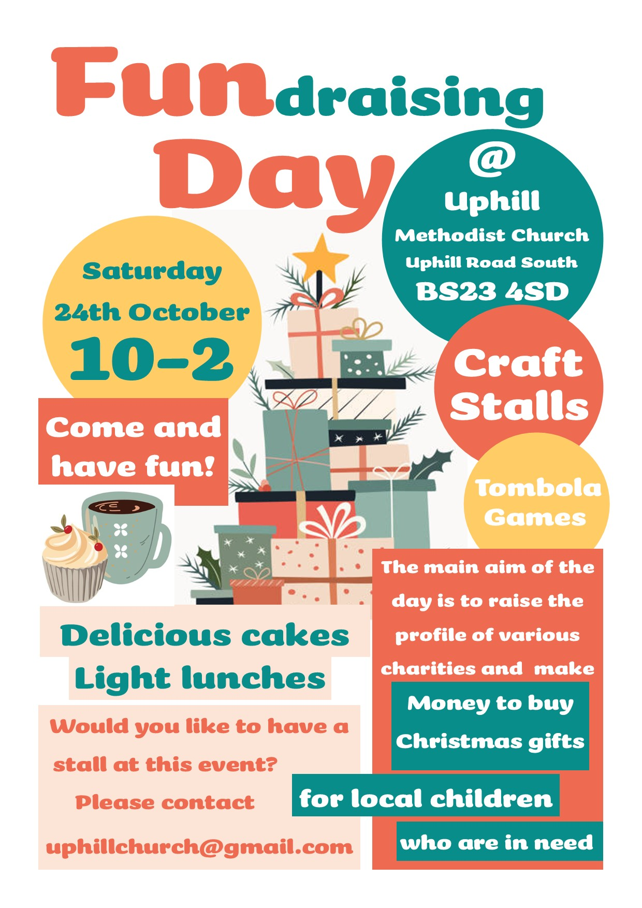
Messy Church: Wednesday 4th November.
Theme: Jesus the Light of the World.
We have 2 mums helping as craft leaders. Praise the Lord.
Please pray for the team, that we only have numbers that we can cope with, and the carers and children will hear about Jesus and how He loves us.
This Messy Church follows the "darkness" after Halloween.
We continue to need help with the event and especially admin before and during the event. Is this something you could do?

Shoe Boxes
If you do a shoe box, Home and Office (opposite Tesco) are collecting shoe boxes
from 9th to 16th November.

Locking Deanery Worship Gathering – Sunday 15th November at 4pm (Locking Castle Church)
More details to follow.

Coffee and Cake event: Thursday 19th November 2.30pm
PLEASE NOTE THIS EVENT HAS BEEN REARRANGED FOR NOVEMBER
It will be an afternoon meeting with Rev. Errol King, the new chaplain at the hospice.
Please invite your friends.
If you're available to help in any way, please see Gail.

Mission Team News
Heather Johnstone will be visiting St Nicholas’ Church on Sunday 22nd November.
We shall be hosting a shared lunch in Church after which Heather will speak about Rehema.
At the end of November the Mission Team will be launching their Christmas Appeal. This year
we shall be supporting Jigsaw Kids Ministry (linked to the Church Mission Society) to help children living in extreme poverty in Manila in the Philippines.

Worlewind Band Saturday 5th December 7:30pm

The Christmas tree festival - Friday 11th and Saturday 12th December
We have some trees already booked in. There will be a rota to help serve refreshments during
the 2 days when the church will be open. We will also need cakes.
Help will also be needed to set up on Thursday 10th in the afternoon and to clear away on
Saturday 12th.
Please see Gail if you can help in any way.

Further Changes to Watching our Services Online

St Nicholas Church:
You can no longer join the service by Zoom.
Each service can now be accessed through our YouTube account using this link
https://www.youtube.com/@nicholasuphill.
Each service will have its own button so scroll down and select the date for that Sunday to join the service. You can also watch the recording of recent services.

St Barnabas Church:
PLEASE USE THIS NEW LINK FOR ZOOM FOR ALL FUTURE SERVICES
https://us05web.zoom.us/j/82013765014?pwd=GfAapmXytexNk21ZvpJoBEKZ0xCQuQ

You can also find the YouTube and Zoom links on the home page of the St Nicholas with St Barnabas website - https://www.stnicholaswithstbarnabas.org/

Services
Sunday 18th October 2026
10:00 a.m. – Morning Worship and by Live Stream from St Nicholas
I Am The Way, The Truth and The Life John 14:5-14

Wednesday 21st October 2026
10:30 a.m. – Holy Communion and by Zoom from St Barnabas
Jesus Raises a Dead Girl and Heals a Sick Woman Matthew 9:19-26

Sunday 25th October 2026
10:00 a.m. – Morning Worship and by Live Stream from St Nicholas
The Right to Become Children of God John 1:10-13 Romans 8:12-21

Wednesday 28th October 2026
10:30 a.m. – Morning Worship and by Zoom from St Barnabas
Jesus Heals The Blind and The Mute Matthew 9:27-34

Sunday 1st November 2026
10:00 a.m. – Morning Worship and by Live Stream from St Nicholas
I Am The True Vine John 15:1-17

The next Parish Update will be produced on Friday 30th October.

Please pray:
Joan Bailey - please continue to pray for peace for Joan. She seems depressed and she says she feels confused at times.
Joan Glover
Malcolm and Edna Hunter – Edna says: “Thank you everyone for your prayers. I am so pleased to be able to tell you that WGH have agreed to Malcolm coming home back into my care. There will of course be home care attending to help with personal care. This is something I never expected to see after four months of him being away from home. Please continue to pray that I will have the ability and strength to care for his needs.
My hearing continues to improve slowly. Thank you again for the prayers, it is all Amazing Grace.”
Ada Keeley
Audrey Howell
Lily Insley
Paul and Barbara Lewis
The Madeleys – please see Prayer and Reflection (attached)

Stella Middleton
Sally Moir
Lynn Pack
Gwen Purnell - Gwen is heading towards end of life care. She is comfortable, sleeping much
of the day, with the carers taking care of her comfort. She is eating very little. Liz, Gwen's daughter, visits most days and reads to her or sings from Mission Praise, a copy of which is kept in
Gwen's cupboard.
Mac Reid
Jo Scott
Peter and Val Tullett
Joy White
Gill and David Willis - Please continue to pray for good health for Gill as she looks after David
with Parkinsons.

Prayers for Mission
Pedro Santos - Beit Immanuel is in need of repair and renovation. Please pray for Pedro as he works on that and for CMJ Israel who hold the purse strings. Meanwhile continue to pray for the amazing ministry to Israelis coming as a result of Beit Immanuel being in such a good location and because Pedro will speak to anyone!
The Clarkes
Heather Johnstone, our CMS Mission Partner at Rehema in Tanzania: please continue to pray for Heather as she gets ready to come on leave - preparations at Rehema and for the leave itself.
Alison Giblett, Anya and Pastor Valery, CMS mission partners in Kyiv: Please continue to pray
for them as they seek to meet some of the many needs of those around them, while suffering
the effects of war themselves. Please pray for their safety and of course continue praying
for peace in Ukraine.

Contact Details
Our Church Wardens
Jim: 01934 644623 or loringjim@outlook.com
Lynn: 01934 813763 or lynnmarypack@gmail.com

The Pastoral Team
Pauline Farley 01934 415401
Barbara Lewis 07773 087439 (mobile preferred to landline 633655)
Joy Realff 01934 625545

Parish Office
When Duncan is in the Parish Office it is usually at the following times:
Mondays and Wednesdays 09:00am - 2:00pm, Fridays 2:00 – 4:00pm.
Telephone – 01934 641 863 or 07766 482 850 Email - stnickswithstbs@gmail.com
Duncan is still collecting stamps for charity so please leave any stamps at St B's or let Duncan know.

Instagram, Facebook and Website
Our churches have an Instagram account, which Rachel set up.
The address is st.nicholas.with.st.barnabas (no capitals)
Our Facebook page can be accessed through this link: https://www.facebook.com/StNicksandStBs/
In due course you will be able to find this update under “Parish Newsletter” on our website: https://www.stnicholaswithstbarnabas.org/

Please find attached Jeff’s Prayer and Reflection for October

