Praise and thanks
- Give thanks that the new streaming facility is working well, having now gone live
- For a very uplifting last service for all the Madeleys
- The Gospel sermon series at both St Nicholas and St Barnabas, that Mark has chosen for us
- PCC agreeing five priorities for the parish during the vacancy
- Thank you that a couple of Mums from Messy Church ran a craft table
- That we are getting quite a few new hall bookings at St Barnabas in particular
- For the opportunity for the PCC to meet with the archdeacon and area dean for initial discussions about the proposed pastoral organisation

Praying for the Church
- That the vacancy will be a season of grace and that the wardens and PCC will seek and understand God’s guidance as they lead the church at this time
- For Lynn and Jim, with all their extra responsibilities post Mark. Pray also that they won’t be overwhelmed by all that has to be done.
- For Dave and Annabel as they support Lynn and Jim
- For Jim and Lynn meeting the area dean to arrange cover for both St Nicholas and St Barnabas
- That we can all pull together as a parish as we face a challenging time ahead. That more people will come forward to help
- For Messy Church. We had a disappointing number of children in October (8), partly because Wednesday after school is now a choir practice for an event in Birmingham in January
- That new people would come to join us and not be put off as we don’t have a rector at the moment
- The church hall heaters have been condemned. Pray for Jim as he looks for an appropriate replacement of our existing system to be fitted over half term. It is essential that there is good heating for PreSchool.
- Pray for Annabel balancing the books as we face a large deficit at the end of the year. Pray that we may be able to access a grant for the heaters in this short space of time to alleviate some of this
- Pray that the Diocesan Advisory Committee will finally approve the request to use a TV screen in church

*****

St Nicholas with St Barnabas
Prayers and Reflections (October 2026)

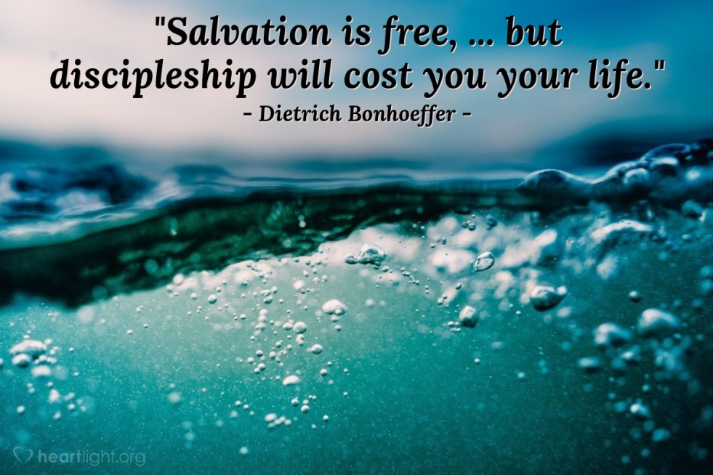

Christianity without discipleship is always Christianity without Christ.
Dietrich Bonhoeffer

We need to share the gospel the way Jesus did, by making the way of discipleship clear.
Zane Pratt
Salvation is free but discipleship costs everything we have.
Billy Graham

Discipleship is a lifestyle filed with relationships; a life of pouring yourself out for others.

Discipleship is about: walking together, learning together, growing together, and pointing each other to Jesus.

True discipleship is measured not by the knowledge one acquires, but by the life one lives.
Bill Hull
Discipleship is the process of becoming like Christ and always begins with a decision.
Rick Warren

Luke 9: 1-5, 23- 27 C.E .V
¹Jesus called together his twelve apostles and gave them complete power over all demons and diseases. ²Then he sent them to tell about God's kingdom and to heal the sick. ³He told them, “Don't take anything with you! Don't take a walking stick or a travelling bag or food or money or even a change of clothes. ⁴When you are welcomed into a home, stay there until you leave that town. ⁵If people won't welcome you, leave the town and shake the dust from your feet as a warning to them.”
²³Then Jesus said to all the people:
If any of you want to be my followers, you must forget about yourself. You must take up your cross each day and follow me. ²⁴If you want to save your life, you will destroy it. But if you give up your life for me, you will save it. ²⁵What will you gain, if you own the whole world but destroy yourself or waste your life? ²⁶If you are ashamed of me and my message, the Son of Man will be ashamed of you when he comes in his glory and in the glory of his Father and the holy angels. ²⁷You can be sure that some of the people standing here will not die before they see God's kingdom.

The Cost of Discipleship Ruby Zephyr/Jeremy Lucas
I dreamed of crowns and glory
But You showed me a crown of thorns
I thought faith was easy favour
But You walked a path of storms
I built my throne in comfort
While You bled for all my pride
Now I see that following You
Means something in me must die

You said, "Follow Me, "
But the road was uphill
You said, "Trust in Me, "
Through the breaking of my will
You never promised comfort
Just the cross and victory's climb
You said, "Follow Me, "
So I left myself behind

I've laid down dreams and idols
The ones I called my own
The fire burns what I can't carry
Until all that's left is stone
You're carving something holy
Where ambition used to be
And now I count it all as loss
Just to have You living in me

I've been crucified with Christ
And I no longer live
Every breath I take is mercy
Every step — what You forgive
The weight of the world fell off
When I laid it at Your feet
Now the cost that once seemed heavy
Is the price that made me free

You said, "Follow Me, "
And I walked into the flame
You said, "Die to self, "
And I rose again in Your name
You never promised comfort
But You gave me peace inside
You said, "Follow Me, "
So I left my life behind

"Whoever loses his life for my sake will find it..."

Pray for Mark, Caroline, Rachel and Ben
- Pray for Mark as he continues to seek God’s revelation regarding his future ministry and pray that he will have time too to sort things out at home prior to moving
- Pray for Caroline, as she continues in her challenging job at school, and that she won’t be overburdened. Help her to continue to be a witness there
- Give thanks for Caroline for all her hard work as she continues to guide us in using the sound and vision system.
- Praise God that Rachel continues to enjoy her teaching job, despite some of the issues reception children bring!
- Thank you that she has loads of friends and is enjoying staying with the family who is hosting her
- Praise the Lord that Ben has now got a room in a house with a lovely Christian family, not far from the university.
- Give thanks too that he is really enjoying his course and has made new friends

Do continue to hold this family before the Lord in prayer

